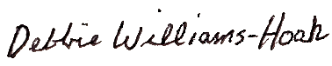

Presented To

~ Name~

Spring 2021

Honorable Mention All-State

Division 3

MIGCA President

Coach